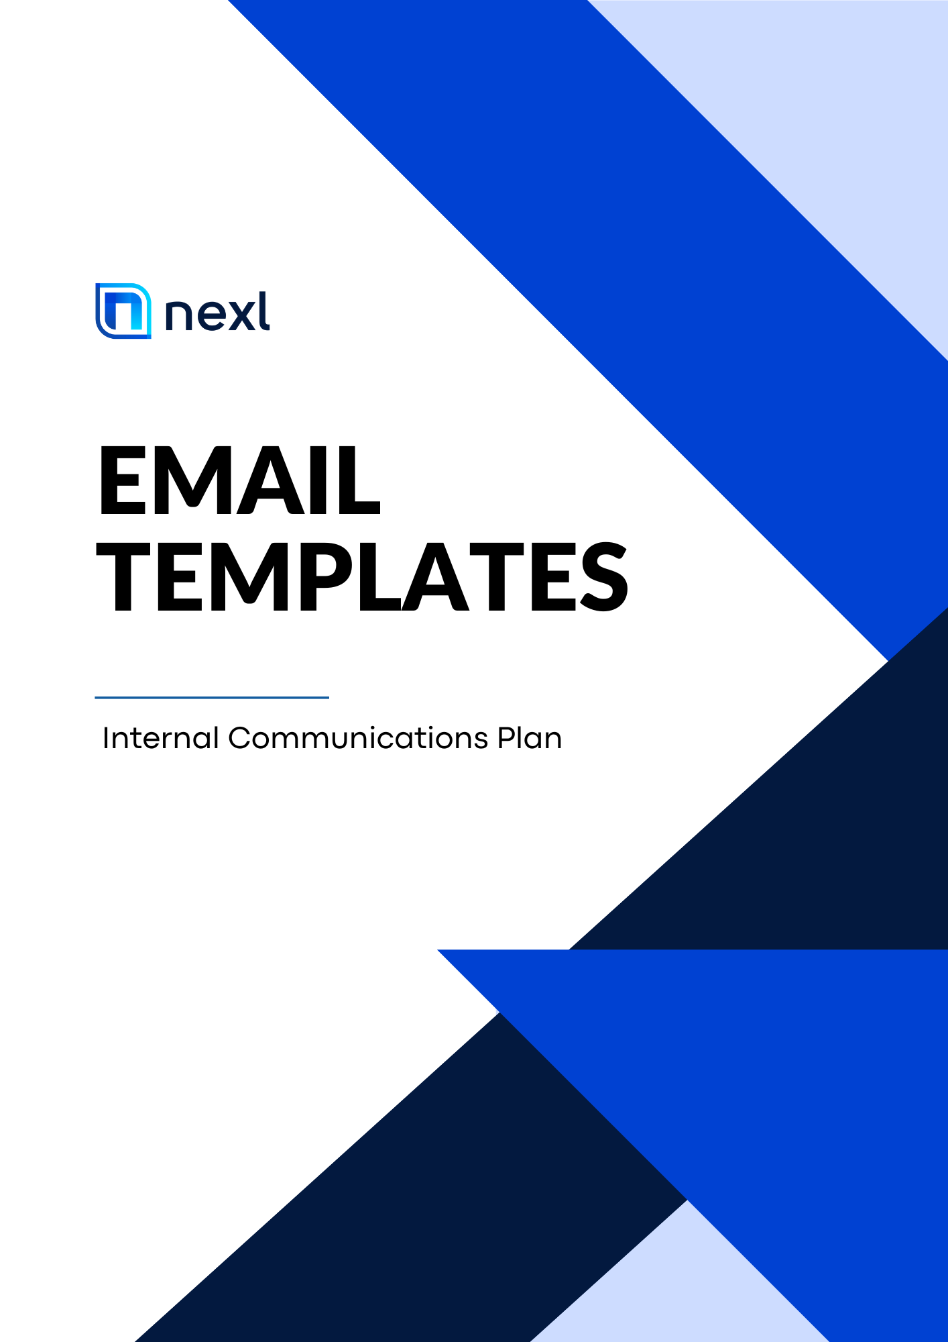

Introduction

Thank you for downloading this email template guide! We are excited to work with you to design an Internal Communications Plan to complement your Nexl implementation and relay key information throughout your firm.

These templates are designed to be used in conjunction with our Internal Communications Plan document and Template Images file. The Internal Communications Plan sets out the details of when and why to use each email template—including suggested sender and audience, and the milestones at which we recommend sending each email—and the Template Images file provides a zip file of images and brand assets for your use within your email campaigns. You can download the Internal Communications Plan and Template Images files at https://nexl.cloud/comms. We encourage you to explore the additional resources and assets available for download as well!

This document is designed to provide our recommended designs and layouts, while still allowing you to customize the text, add your firm branding, and use your own email and marketing tools. On each of the following pages, you’ll find two columns: (1) a recommended layout on the left, and (2) the text within the design on the right. We suggest that you copy / paste the text and upload the images into your email marketing system, where you can then create the designs and layouts as you see fit.

We hope this proves to be a helpful resource and look forward to seeing your internal communications come to life!

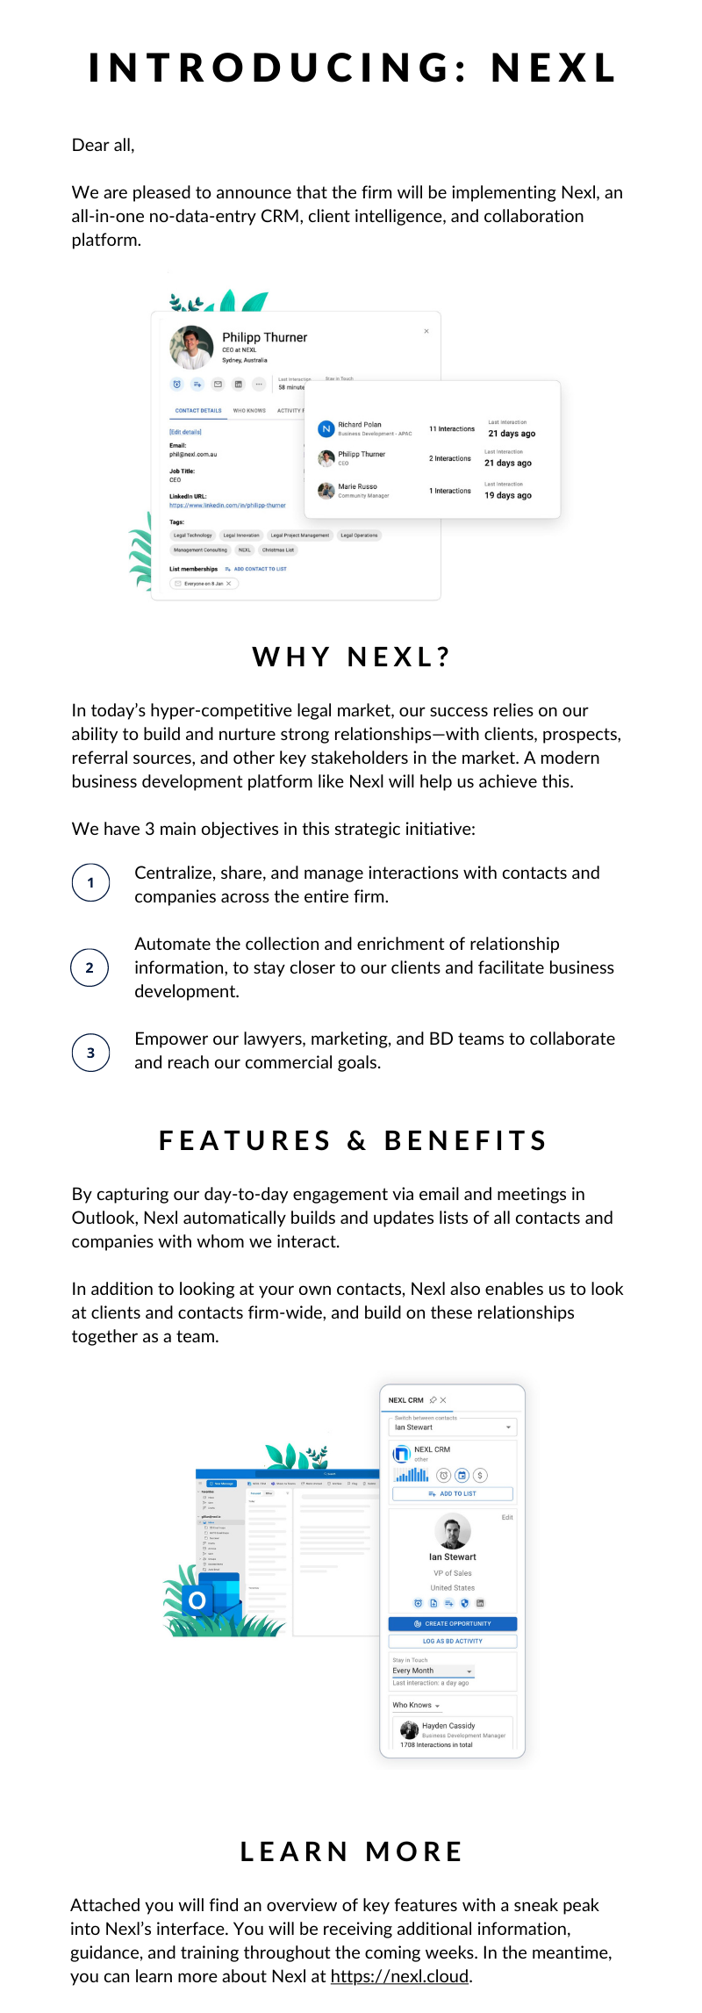 | E M A I L 1:  I N T R O D U C I N G N E X L  _______________________  INTRODUCING: NEXL  Dear all,  We are pleased to announce that the firm will be implementing Nexl, an all-in-one no-data-entry CRM, client intelligence, and collaboration platform.  WHY NEXL?  In today’s hyper-competitive legal market, our success relies on our ability to build and nurture strong relationships—with clients, prospects, referral sources, and other key stakeholders in the market. A modern business development platform like Nexl will help us achieve this.  We have 3 main objectives in this strategic initiative:  - Centralize, share, and manage interactions with contacts and companies across the entire firm.  - Automate the collection and enrichment of relationship information, to stay closer to our clients and facilitate business development.  - Empower our lawyers, marketing, BD, and business services teams to collaborate and reach our commercial goals.  FEATURES & BENEFITS  By capturing our day-to-day engagement via email and meetings in Outlook, Nexl automatically builds and updates lists of all contacts and companies with whom we interact.  In addition to looking at your own contacts, Nexl also enables us to look at clients and contacts firm-wide, and build on those relationships together as a team.  LEARN MORE  Attached you will find an overview of key features with a sneak peek into Nexl’s interface. You will be receiving additional information, guidance, and training throughout the coming weeks. In the meantime, you can learn more about Nexl at https://nexl.cloud.

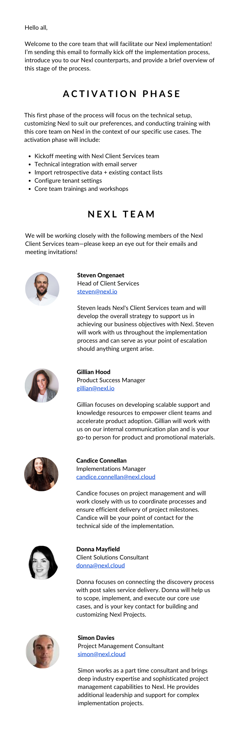 | E M A I L 2:  N E X L I M P L E M E N T A T I O N  T E A M  _______________________  Hello all,  Welcome to the core team that will facilitate our Nexl implementation! I’m sending this email to formally kick off the implementation process, introduce you to our Nexl counterparts, and provide a brief overview of this stage of the process.  ACTIVATION PHASE  This first phase of the process will focus on the technical setup, customizing Nexl to suit our preferences, and conducting training with this core team on Nexl in the context of our specific use cases. The activation phase will include:  - Kickoff meeting with Nexl’s Client Services team  - Technical integration with email server  - Import retrospective data + existing contact lists  - Configure tenant settings  - Schedule core team trainings and workshops  NEXL TEAM  We will be working closely with the following members of the Nexl Client Services team—please keep an eye out for their emails and meeting invitations!  Steven Ongenaet  Head of Client Services  steven@nexl.io  Steven leads Nexl's Client Services team and will develop the overall strategy to support us in achieving our business objectives with Nexl. Steven will work with us throughout the implementation process and can serve as your point of escalation should anything urgent arise.  _______________________  C O N T I N U E D O N N E X T P A G E

Gillian Hood
Product Success Manager
gillian@nexl.io

Gillian focuses on developing scalable support and knowledge resources to empower client teams and accelerate product adoption. Gillian will work with us on our internal communication plan and is your go-to person for product and promotional materials.

Candice Connellan
Implementations Manager
candice.connellan@nexl.cloud

Candice focuses on project management and will work closely with us to coordinate processes and ensure efficient delivery of project milestones. Candice will be your point of contact for the technical side of the implementation.

Donna Mayfield
Client Solutions Consultant
donna@nexl.cloud

Donna focuses on connecting the discovery process with post sales service delivery. Donna will help us to scope, implement, and execute our core use cases, and is your key contact for building and customizing Nexl Projects.

Simon Davies
Project Management Consultant
simon@nexl.cloud

Simon brings deep industry expertise and sophisticated project management capabilities to Nexl. He provides additional leadership and support for complex implementation projects.

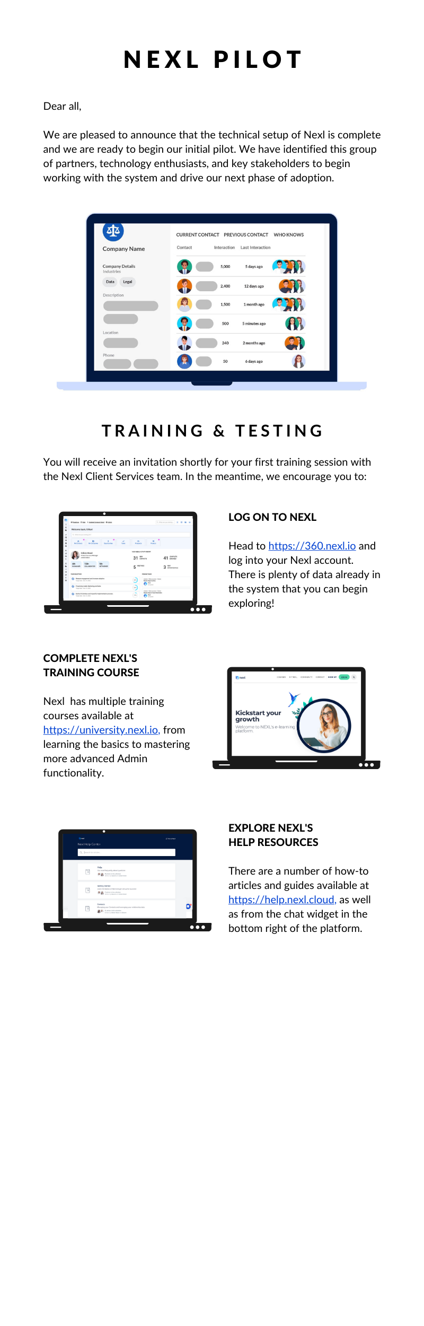 | E M A I L 3:  N E X L P I L O T P R O G R A M  _______________________  NEXL PILOT  Dear all,  We are pleased to announce that the technical setup of Nexl is complete and we are ready to begin our initial pilot. We have identified this group of partners, technology enthusiasts, and key stakeholders to begin working with the system and drive our next phase of adoption.  TRAINING & TESTING  You will receive an invitation shortly for your first training session with the Nexl Client Services team. In the meantime, we encourage you to:  LOG ON TO NEXL  Head to https://360.nexl.io and log into your Nexl account. There is plenty of data already in the system that you can begin exploring!  COMPLETE NEXL’S TRAINING COURSE  Nexl has multiple training courses available at https://university.nexl.io, from learning the basics to mastering more advanced Admin functionality.  EXPLORE NEXL’S HELP RESOURCES  There are a number of how-to articles and guides available at https://help.nexl.cloud, as well as from the chat widget in the bottom right of the platform.

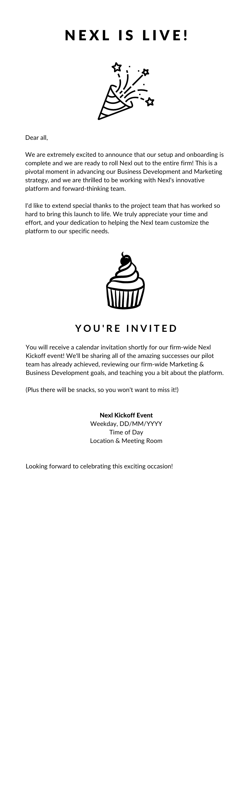 | E M A I L 4:  N E X L I S O F F I C I A L L Y L I V E !  _______________________  NEXL IS LIVE!  Dear all,  We are extremely excited to announce that our setup and onboarding is complete and we are ready to roll Nexl out to the entire firm! This is a pivotal moment in advancing our Business Development and Marketing strategy, and we are thrilled to be working with Nexl's innovative platform and forward-thinking team.  I'd like to extend special thanks to the project team that has worked so hard to bring this launch to life. We truly appreciate your time and effort, and your dedication to helping the Nexl team customize the platform to our specific needs.  YOU’RE INVITED  You will receive a calendar invitation shortly for our firm-wide Nexl Kickoff event! We'll be sharing all of the amazing successes our pilot team has already achieved, reviewing our firm-wide Marketing & Business Development goals, and teaching you a bit about the platform.  (Plus there will be snacks, so you won't want to miss it!)  Nexl Kickoff Event  Weekday, DD/MM/YYYY  Time of Day  Location & Meeting Room  Looking forward to celebrating this exciting occasion!

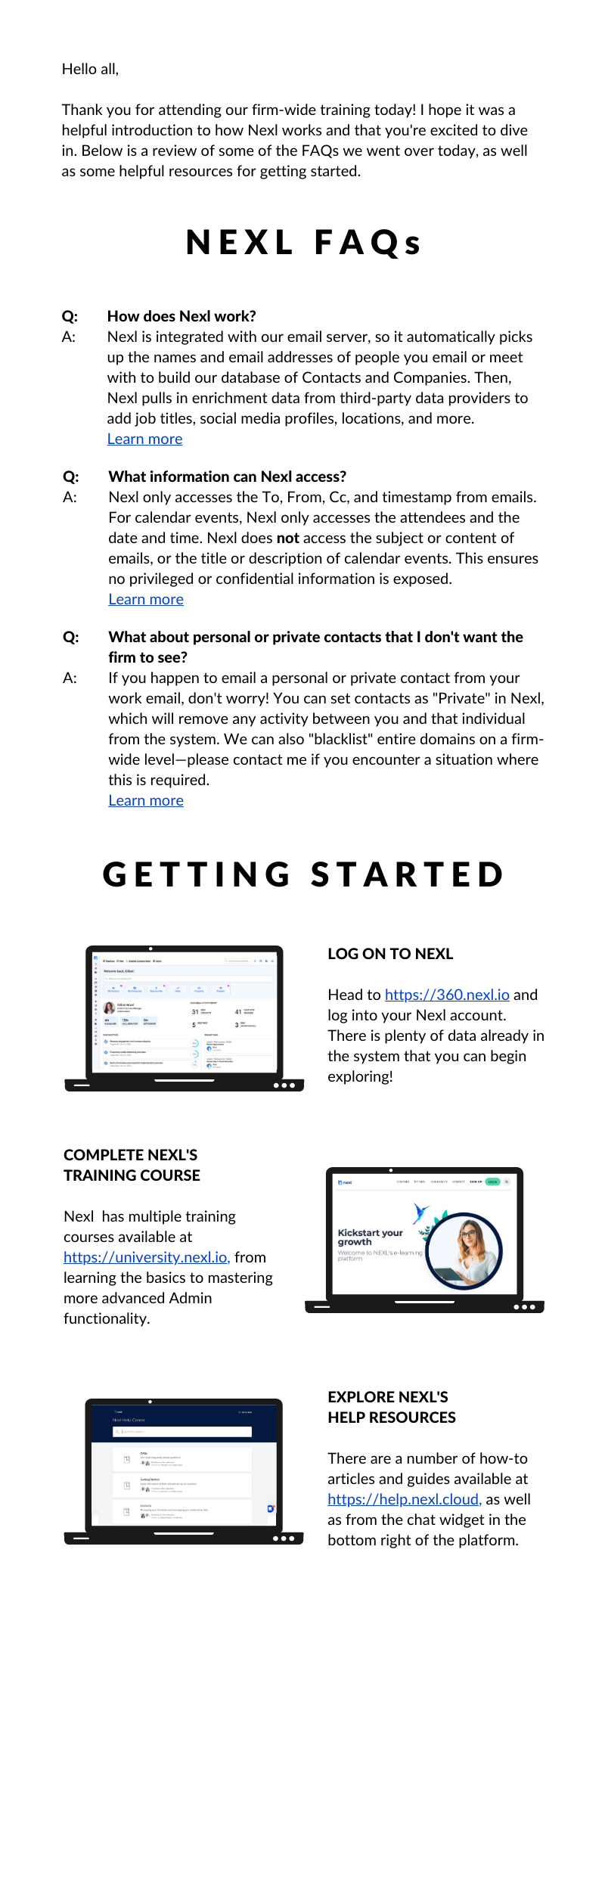 | E M A I L 5:  G E T T I N G S T A R T E D W I T H N E X L  _______________________  Hello all,  Thank you for attending our firm-wide training today! I hope it was a helpful introduction to how Nexl works and that you're excited to dive in. Below is a review of some of the FAQs we went over today, as well as some helpful resources for getting started.  NEXL FAQs  Q: How does Nexl work?  A: Nexl is integrated with our email server, so it automatically picks up the names and email addresses of people you email or meet with to build our database of Contacts and Companies. Then, Nexl pulls in enrichment data from third-party data providers to add job titles, social media profiles, locations, and more.  Learn more  Q: What information can Nexl access?  A: Nexl only accesses the To, From, Cc, and timestamp from emails. For calendar events, Nexl only accesses the attendees and the date and time. Nexl does not access the subject or content of emails, or the title or description of calendar events. This ensures no privileged or confidential information is exposed.  Learn more  Q: What about personal or private contacts that I don't want the firm to see?  A: If you happen to email a personal or private contact from your work email, don't worry! You can set contacts as "Private" in Nexl, which will remove any activity between you and that individual from the system. We can also "blacklist" entire domains on a firm-wide level—please contact me if you encounter a situation where this is required.  Learn more  _______________________  C O N T I N U E D O N N E X T P A G E

GETTING STARTED

LOG ON TO NEXL

Head to https://360.nexl.io and log into your Nexl account. There is plenty of data already in the system that you can begin exploring!

COMPLETE NEXL’S TRAINING COURSE

Nexl has multiple training courses available at https://university.nexl.io, from learning the basics to mastering more advanced Admin functionality.

EXPLORE NEXL’S HELP RESOURCES

There are a number of how-to articles and guides available at https://help.nexl.cloud, as well as from the chat widget in the bottom right of the platform.

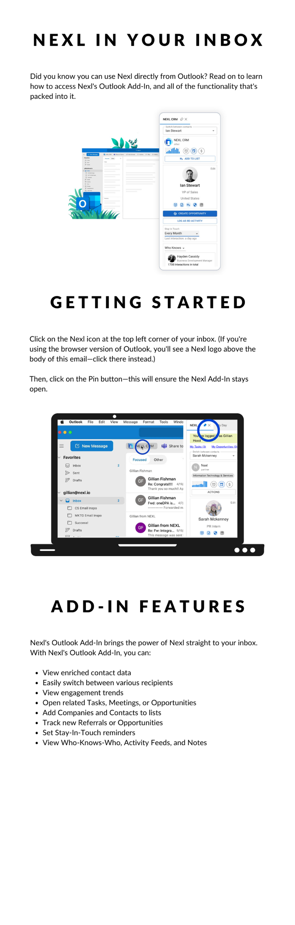 | E M A I L 6:  N E X L ' S O U T L O O K A D D – I N  _______________________  NEXL IN YOUR INBOX  Did you know you can use Nexl directly from Outlook? Read on to learn how to access Nexl's Outlook Add-In, and all of the functionality that's packed into it.  GETTING STARTED  Click on the Nexl icon at the top left corner of your inbox. (If you're using the browser version of Outlook, you'll see a Nexl logo above the body of this email—click there instead.)  Then, click on the Pin button—this will ensure the Nexl Add-In stays open.  ADD-IN FEATURES  Nexl's Outlook Add-In brings the power of Nexl straight to your inbox. With Nexl's Outlook Add-In, you can:  - View enriched contact data  - Easily switch between various recipients  - View engagement trends  - Open related Tasks, Meetings, or Opportunities  - Add Companies and Contacts to lists  - Track new Referrals or Opportunities  - Set Stay-In-Touch reminders  - View Who-Knows-Who, Activity Feeds, and Notes

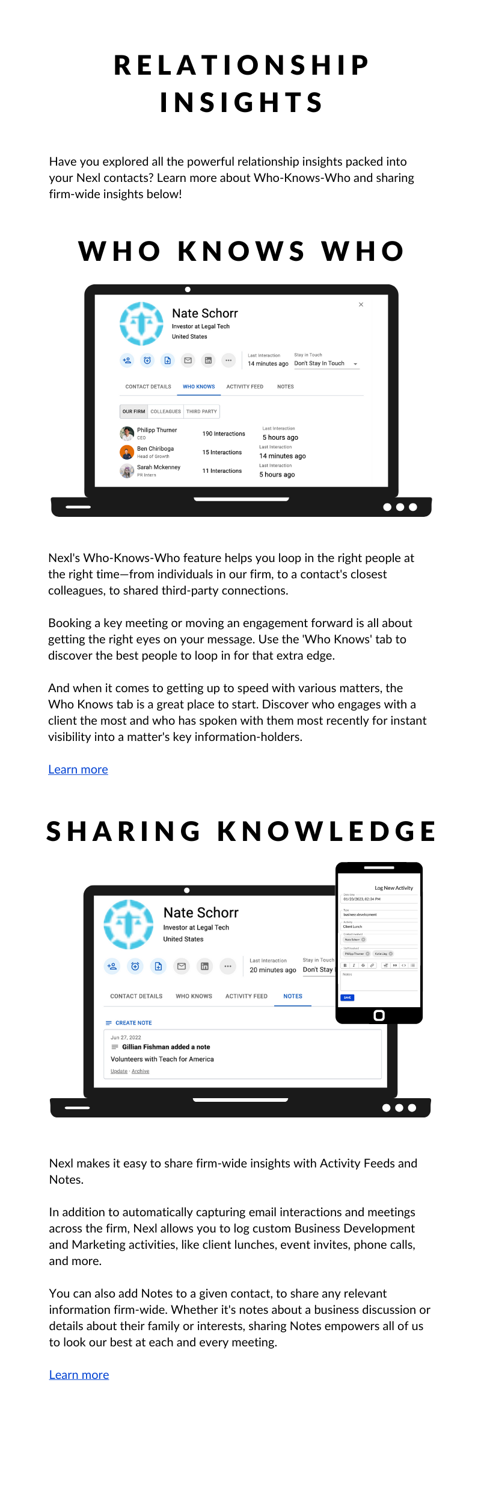 | E M A I L 7:  U N C O V E R I N G R E L A T I O N S H I P  I N S I G H T S W I T H N E X L  _______________________  RELATIONSHIP INSIGHTS  Have you explored all the powerful relationship insights packed into your Nexl contacts? Learn more about Who-Knows-Who and sharing firm-wide insights below!  WHO KNOWS WHO  Nexl's Who-Knows-Who feature helps you loop in the right people at the right time—from individuals in our firm, to a contact's closest colleagues, to shared third-party connections.  Booking a key meeting or moving an engagement forward is all about getting the right eyes on your message. Use the 'Who Knows' tab to discover the best people to loop in for that extra edge.  And when it comes to getting up to speed with various matters, the Who Knows tab is a great place to start. Discover who engages with a client the most and who has spoken with them most recently for instant visibility.  Learn more  SHARING KNOWLEDGE  Nexl makes it easy to share firm-wide insights with Activity Feeds and Notes.  In addition to automatically capturing email interactions and meetings across the firm, Nexl allows you to log custom Business Development and Marketing activities, like client lunches, event invites, phone calls, and more.  You can also add Notes to a given contact, to share any relevant information firm-wide. Whether it's notes about a business discussion or details about their family or interests, sharing Notes empowers all of us to look our best at each and every meeting.  Learn more

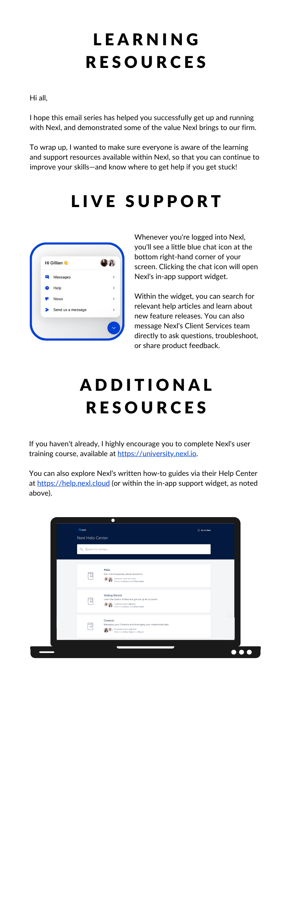 | E M A I L 8:  N E X L L E A R N I N G R E S O U R C E S  _______________________  LEARNING RESOURCES  Hi all,  I hope this email series has helped you successfully get up and running with Nexl, and demonstrated some of the value Nexl brings to our firm.  To wrap up, I wanted to make sure everyone is aware of the learning and support resources available within Nexl, so that you can continue to improve your skills—and know where to get help if you get stuck!  LIVE SUPPORT  Whenever you're logged into Nexl, you'll see a little blue chat icon at the bottom right-hand corner of your screen. Clicking the chat icon will open Nexl's in-app support widget.  Within the widget, you can search for relevant help articles and learn about new feature releases. You can also message Nexl's Client Services team directly to ask questions, troubleshoot, or share product feedback.  ADDITIONAL RESOURCES  If you haven't already, I highly encourage you to complete Nexl's user training course, available at https://university.nexl.io.  You can also explore Nexl's written how-to guides via their Help Center at https://help.nexl.cloud (or within the in-app support widget, as noted above).

